

Intelequia VR Team  
Versión 1.0

*August 13, 2017*

Hackathon Open Challenge

Mixed Reality with Hololens

Table of contents

1. Introduction 2

2. Prerequisites 3

2.1. Visual Studio 3

2.2. Hololens Emulator 4

2.3. Unity3D 5

2.4. System Requirements 5

3. How to make Holograms 7

3.1. Configure your 3D software 7

3.2. Meshes 8

3.3. Textures 10

3.4. UV Mapping 10

3.5. Animation 11

3.6. Export your Hologram 13

4. How to create Unity scene 15

4.1. Configuring a Unity project 15

# Introduction

This document is a start-up guide to help developers of BBVA's Open Challenge to prepare their Mixed Reality (MR) projects using Microsoft holographic technology.

The aim of the developers is to design a MR solution to improve the work space of the trader of the future.

But developing high quality MR projects requires prior knowledge such as:

* Animation, lighting and modeling of 3D objects.
* Scheduling scenes with Unity3D.

And also some experience with Hololens, the hardware device Head Mounted Display (HMD) designed by the Microsoft team.

For this reason the organization of the event has decided to democratize the contest allowing the developers to do their projects using only the emulator and later providing them a Hololens for their presentation in Chicago. This prevents the developer from having the Hololens hardware, which is currently in a development phase, with a high price and geographical limitation for its distribution.

This guide, therefore, collects in an organized way the basic procedures and techniques necessary to successfully execute a MR project in the Hololens simulator provided in the latest versions of Microsoft Visual Studio.

Finally, you can note that this guide has been developed by Intelequia VR Team. Any doubts or clarifications that contestants have about the procedures described can direct it to the mailbox of technical support hololens@intelequia.com, indicating in the body of the same the data of registry of the contestant.

# Prerequisites

Currently, there is no separate SDK for the development of Windows applications of Mixed Reality for that reason we must use Visual Studio with the Windows SDK 10 (version 1511 or higher). Therefore, Mixed Reality Apps are developed with the same tools as the Windows Store Apps.

Thanks to the existence of the Hololens emulator you do not need to have a physical device to develop or test your Mixed Reality Apps.

Although it is not strictly necessary, we recommend using the Unity3D game engine so that the development of your Apps is much easier. In this Hackaton only support will be given to the projects made with this engine.



## Visual Studio

Although the version of Visual Studio 2015 Update 3 is also supported, we recommend using Visual Studio 2017 for a better experience. All editions of Visual Studio are supported including the Community.

During the installation of Visual Studio we must select **Universal Windows Platform development**:

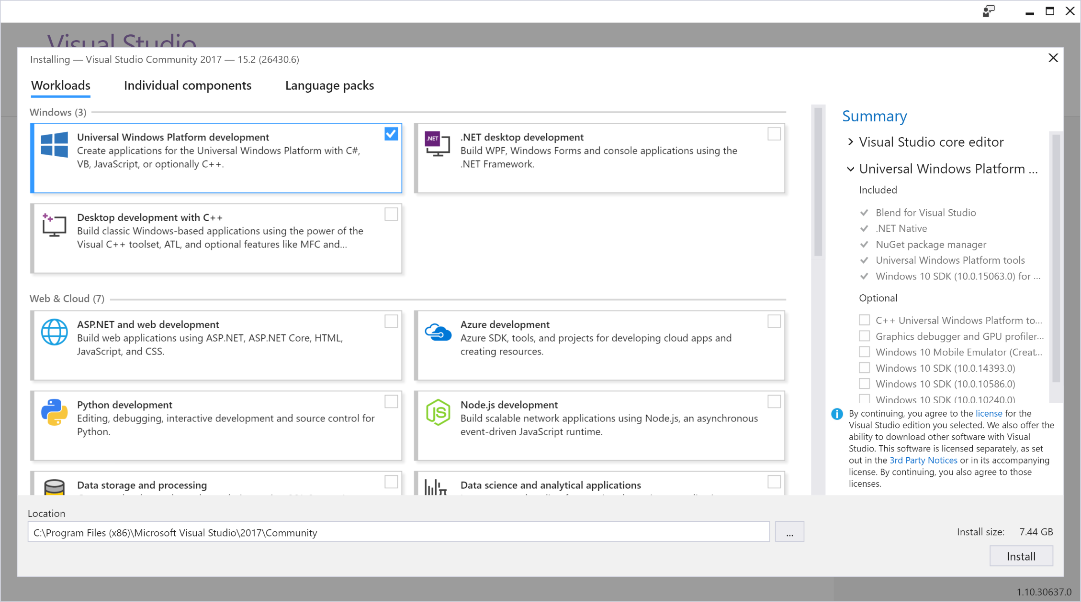

If we are not going to install any version 5.6.0f3 or higher of Unity3D we will also select the components **Game Development with Unity**

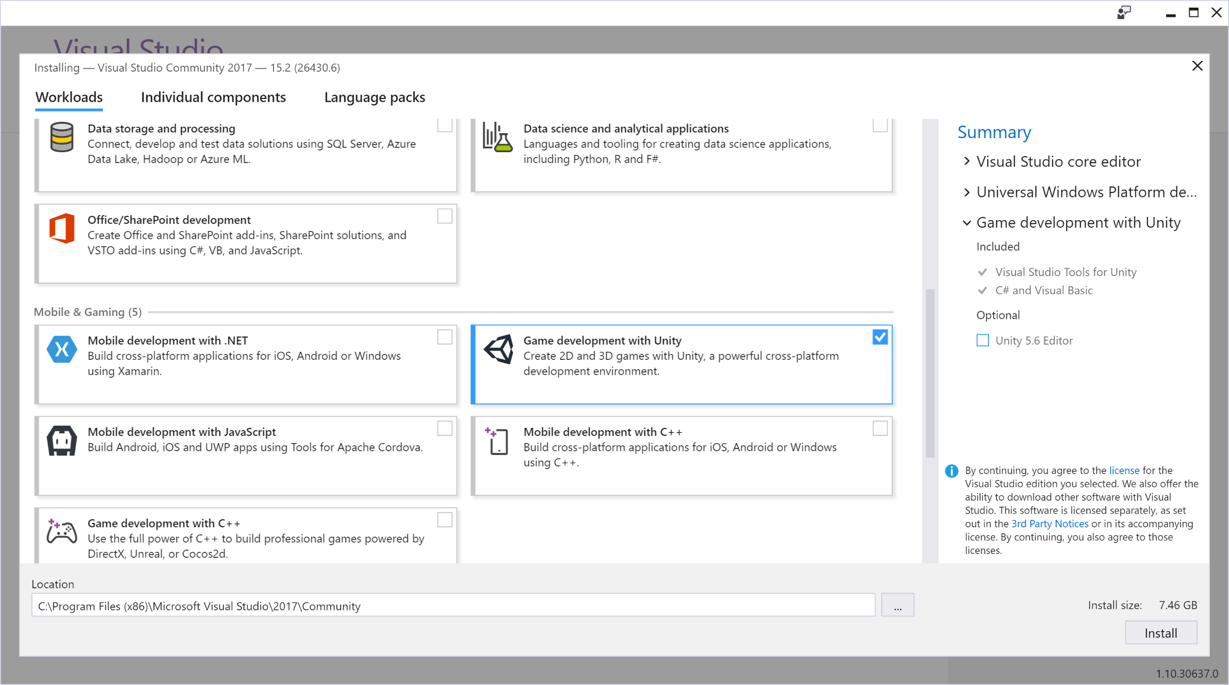

You can download a copy of the Visual Studio Community for free by accepting the terms of use. To see all the available downloads, consult this address: <https://developer.microsoft.com/en-us/windows/downloads>

## Hololens Emulator

The emulator will allow you to run Windows Holographic applications on a virtual machine without needing a physical Hololens. This includes a virtual image of Hololens running the latest version of Windows Holographic OS. If you have already installed a previous version of the emulator, this build will install side-by-side.

**Your system must support Hyper-V** for the installation to run successfully. See system requirements for more details.

You can download the emulator from the following address: <https://go.microsoft.com/fwlink/?linkid=852626>

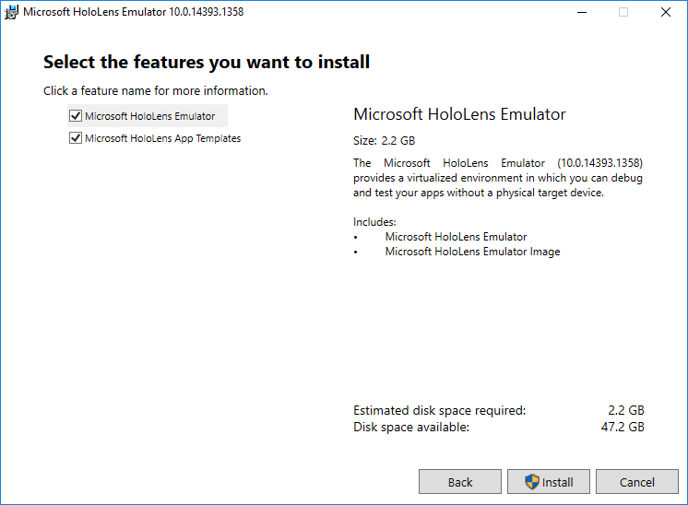

## Unity3D

The Unity3D gaming engine accelerates the development of holographic applications and seamlessly integrates with the Windows 10 SDK to produce solutions compatible with Visual Studio 2015 or 2017.

You can get version 5.6 or higher (including the recent 2017.1) from its official site: <https://store.unity.com/download>

## System Requirements

The first requirement is that you have the Windows 10 SDK (included in the Windows Universal Application Development package that you can select during the Visual Studio installation). This SDK where it works best is in the operating system Windows 10 but is also supported in Windows 8.1, Windows 8, Windows 7, Windows Server 2012 and Windows Server 2008 R2.

On the other hand, the requirements for the installation of Visual Studio 2017 are:

* Sistema Operativo:
  + Windows 10 version 1507 or higher: Home, Professional, Education, and Enterprise (LTSB and S are not supported)
  + Windows Server 2016: Standard and Datacenter
  + Windows 8.1 (with [Update 2919355](https://support.microsoft.com/kb/2919355)): Core, Professional, and Enterprise
  + Windows Server 2012 R2 (with [Update 2919355](https://support.microsoft.com/kb/2919355)): Essentials, Standard, Datacenter
  + Windows 7 SP1 (with latest Windows Updates): Home Premium, Professional, Enterprise, Ultimate
* Hardware:
  + 1.8 GHz or faster processor. Dual-core or better recommended
  + 2 GB of RAM; 4 GB of RAM recommended (2.5 GB minimum if running on a virtual machine)
  + Hard disk space: 1GB to 40GB, depending on features installed
  + Video card that supports a minimum display resolution of 720p (1280 by 720); Visual Studio will work best at a resolution of WXGA (1366 by 768) or higher

The HoloLens emulator is based on Hyper-V and uses RemoteFx for hardware accelerated graphics. To use the emulator, make sure your PC meets these hardware requirements:

* Software:
  + 64-bit Windows 10 Pro, Enterprise, or Education (The Home edition does not support Hyper-V or the HoloLens emulator)
  + DirectX 11.0 or later
  + WDDM 1.2 driver or later
* Hardware:
  + 64-bit CPU with 4 cores (or multiple CPU's with a total of 4 cores)
  + 8 GB of RAM or more
  + In the BIOS, the following features must be supported and enabled:
    - Hardware-assisted virtualization
    - Second Level Address Translation (SLAT)
    - Hardware-based Data Execution Prevention (DEP)

If your system meets the above requirements, **please ensure that the "Hyper-V" feature has been enabled on your system** through Control Panel -> Programs -> Programs and Features -> Turn Windows Features on or off -> ensure that "Hyper-V" is selected for the Emulator installation to be successful.

# How to make Holograms

In this section we will explain how you can create holograms. That is, 3D elements suitable for loading into your Unity3D scenes.

We advise using professional 3D modeling tools like [Maya3D](https://www.autodesk.es/products/maya/overview) or [3DS MAX](https://www.autodesk.es/products/3ds-max/overview) and understand that you have the basic knowledge of artistic design.



## Configure your 3D software

Set your system and project units to Metric for your software to work consistently with Unity. The system unit default for Maya is centimeters.

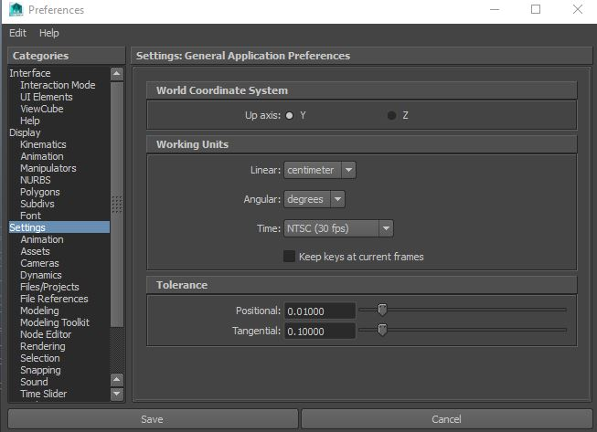

**Get the scale right from the beginning**. Make art so that they can all be imported at a scale factor of 1, and that their transforms can be scaled 1, 1, 1. Use a reference object (a Unity cube) to make scale comparisons easy. Choose a world to Unity units ratio suitable for your game, and stick to it.

Make sure you check the FBX import and export scale settings in Inspector.

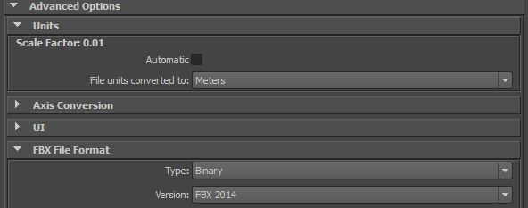

Animation frame rate defaults can be different in different packages, it is a good idea to set this consistently across your pipeline (for example, at 30fps).

Name objects in your Scene sensibly and uniquely. Avoid special characters such as *()?"#$.

Use simple but descriptive names for both objects and files in order to allow for duplication later

Keep your hierarchies as simple as you can.

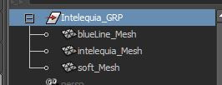

## Meshes

Build with an efficient topology. Use polygons only where you need them.

Optimise your geometry if it has too many polygons.

Where you can afford them, evenly spaced polygons in buildings, landscape and architecture will help spread lighting and avoid awkward kinks.

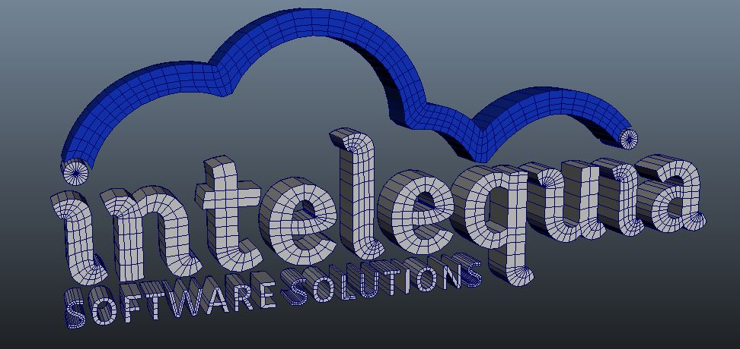

The method you use to construct objects can have a massive effect on the number of polygons, especially when not optimized. A good rule of thumb is often to start simple and add detail where needed. It’s always easier to add polygons than take them away.

**Put character and standing object pivots at the base, not in the centre.** This makes it easy to put characters and objects on the floor precisely. It also makes it easier to work with 3D as if it is 2D for game logic, AI, and even physics when appropriate.

Remember to Freeze the transformations and **delete the history mesh**.

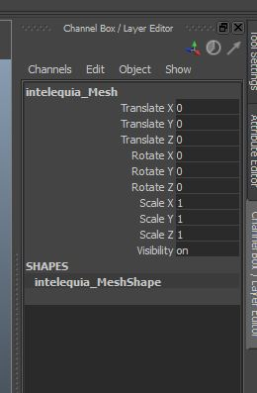

**Make all meshes face in the same direction (positive or negative z axis).** This applies to meshes such as characters and other objects that have a concept of facing direction.

## Textures

If you author your textures to a power of two (for example, 512x512 or 256x1024), the textures will be more efficient and won’t need rescaling at build time. You can use up to 4096x4096 pixels, but 2048x2048 is the highest available on many graphics cards and platforms.

Work with a high-resolution source file outside your Unity project. You can always downsize from the source, but not the other way round.

Make sure your 3D working file refers to the same Textures, for consistency when you save or export.

For alpha and elements that may require different Shaders, separate the Textures.

Make use of tiling Textures which seamlessly repeat. This allows you to use better resolution repeating over space.

## UV Mapping

UV mapping are used to project a 2D image to a 3D model's surface for texture mapping.

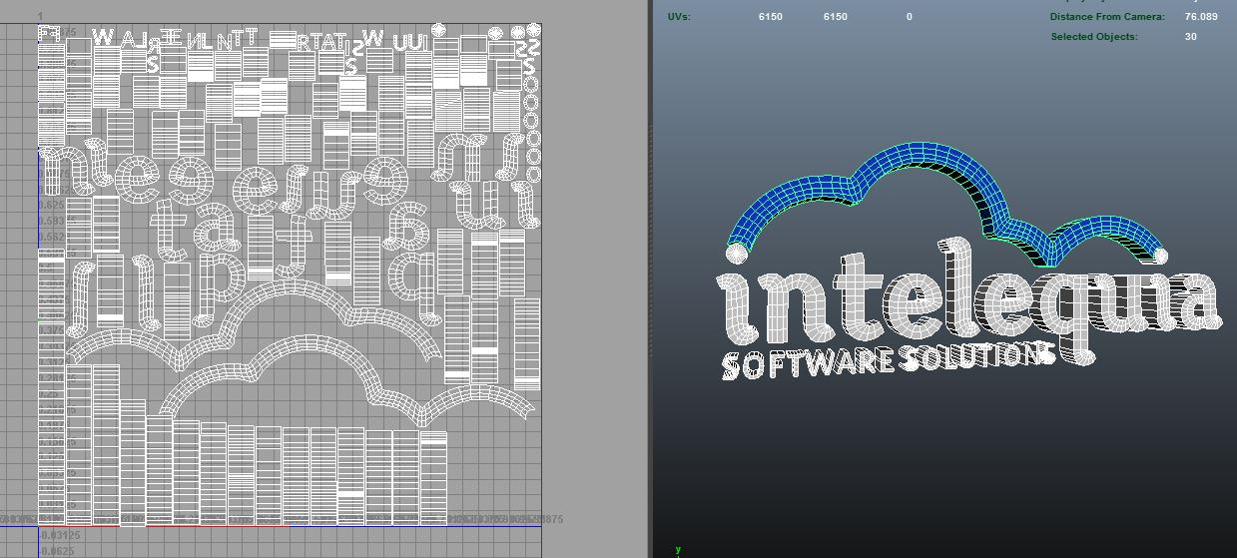

Unity also uses a second UV Set for the Lightmap process.

The Lightmap is technically a second UV Map. The Unity engine needs it to bake lightning information onto the model. You can have Unity create the Lightmap on its own while importing the mesh but we recommend to build your own on a second UV Map channel **avoiding overlapping faces on your LIghtmapping UV set.**

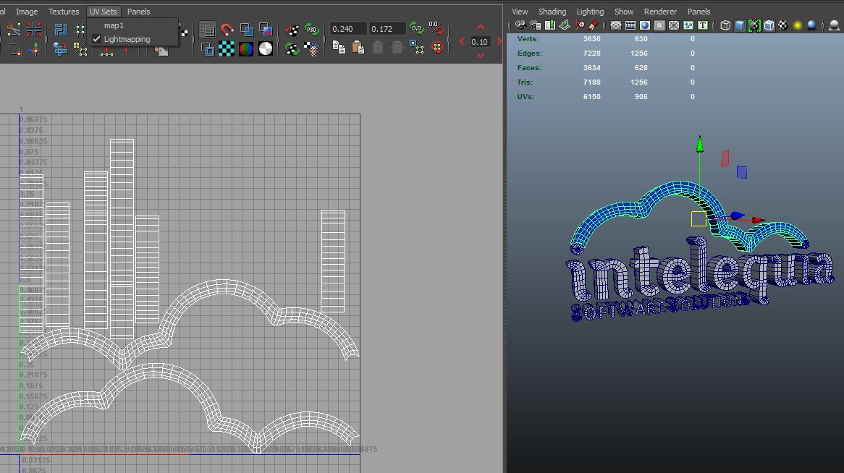

## Animation

You will use most of the times two types of animation, objects moving on the 3d space or joint driven systems such as humanoids characters.

When you have only 3d objects moving (without a joint system and a skinned mesh), its recommended not to bake your animation on your 3d software. Just make your animation with the keyframes you need and export it.

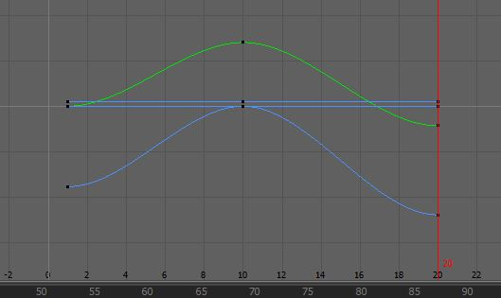

If you need to export humanoid animations make sure you just export your joint hierarchy system and the skinned mesh. The joint system must be baked, not the mesh. Baking a simulation allows you to generate a single animation curve for an object whose actions are being provided by simulation rather than by keys and animation curves (keysets).

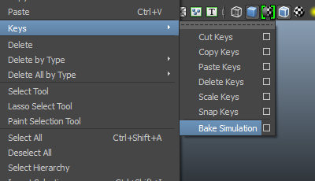

Use your first 5 to 10 frames of your timeline to store a T-Pose of your character to configure your avatar on Unity.

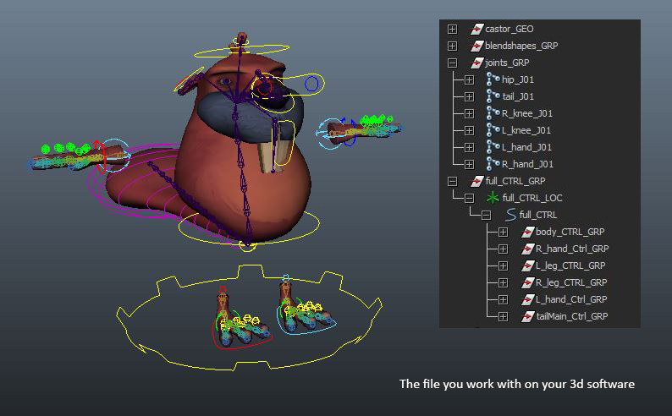

After your animation is done, select all your binded joints and bake that simulation to store a key on every frame. Then delete your control rig and export only the joint system and the mesh. You can delete your Blendshapes, they are stored on the main Mesh.

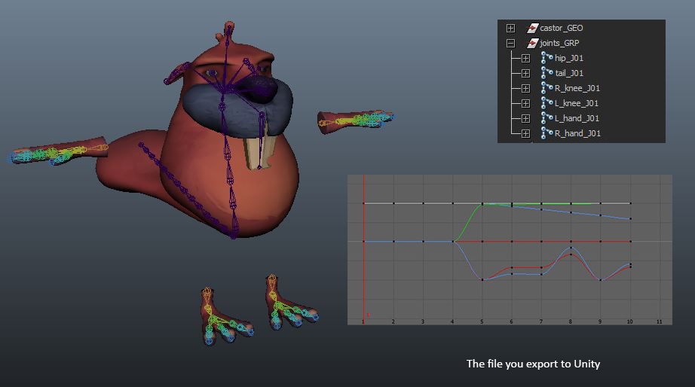

## Export your Hologram

The most common file type is FBX. It can store mesh and animation data.

For static objects uncheck the animation settings.

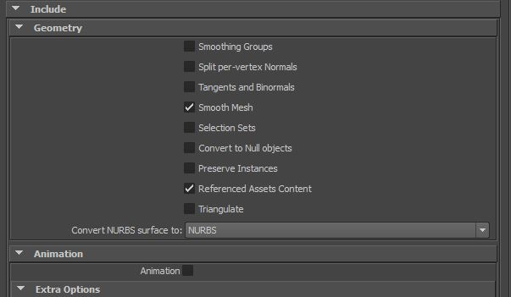

For animated Holograms you have to check the animation setting. If you have skinned meshes remember to bake your animation before exporting it, you can also do it here in the export settings but it’s not recommended. Also check the Blend Shape option if your mesh has them.

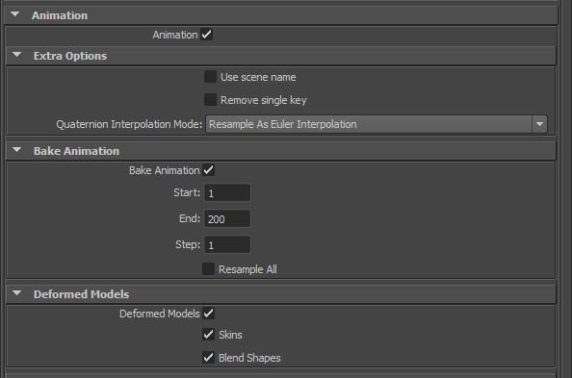

# How to create Unity scene

The fastest path to building a [mixed reality app](https://developer.microsoft.com/en-us/windows/mixed-reality/app_views) is with [Unity](http://aka.ms/HoloLensUnity). We recommend you take the time to explore the [Unity tutorials](https://unity3d.com/learn/tutorials). If you need assets, Unity has a comprehensive [Asset Store](https://www.assetstore.unity3d.com/). Once you have built up a basic understanding of Unity, you can visit the [Mixed Reality Academy](https://developer.microsoft.com/en-us/windows/mixed-reality/academy) to learn the specifics of mixed reality development with Unity. Be sure to visit the [Unity Mixed Reality forums](http://forum.unity3d.com/forums/hololens.102/) to engage with the rest of the community building mixed reality apps in Unity and find solutions to problems you might run into.

Now that you have seen how you can create and export your professional holograms in FBX format, it is time for you to create your first Unity3D project where you can import these elements into scenes that allow you to interact with Hololens capabilities.



## Configuring a Unity project

If you've just created a new Unity project, there are a small set of Unity settings you'll need to change for Windows Mixed Reality, broken down into two categories: per-project and per-scene.

**Per-project settings**

To target Windows Mixed Reality, you first need to set your Unity project to export as a Universal Windows Platform app:

1. Select **File > Build Settings...**

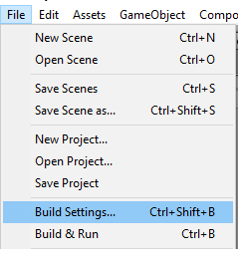

1. Select **Windows Store** in the Platform list and click **Switch Platform**
2. Set **Target device** to **Any Device** to support immersive headsets or switch to **HoloLens**
3. Set **Build Type** to **D3D**
4. Set **UWP SDK** to **Latest installed**

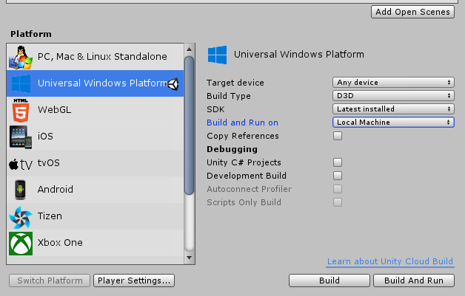

We then need to let Unity know that the app we are trying to export should create an [immersive view](https://developer.microsoft.com/en-us/windows/mixed-reality/app_views) instead of a 2D view. We do that by enabling "Virtual Reality Supported":

1. From the **Build Settings...** window, open **Player Settings...**

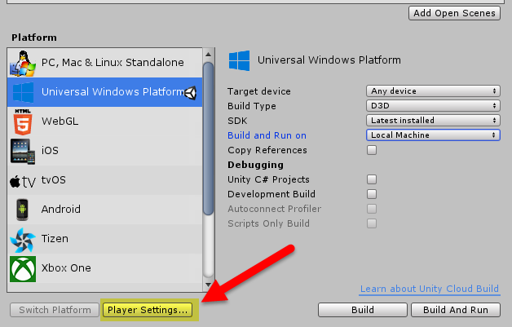

1. Select the **Settings for Windows Store** tab
2. Expand the **Other Settings** group
3. In the **Rendering** section, check the **Virtual Reality Supported** checkbox to add a new **Virtual Reality SDKs** list and confirm **"Windows Holographic"** is listed as a supported device.

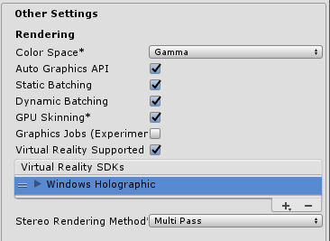

For an app to take advantage of certain functionality, it must declare the appropriate capabilities in its manifest. The manifest declarations can be made in Unity so they are included in every subsequent project export. The setting are found in **Player Settings > Windows Store > Publishing Settings > Capabilities**. The applicable capabilities for enabling the commonly used APIs for Holographic apps are:

|  |  |
| --- | --- |
| **Capability** | **APIs requiring capability** |
| SpatialPerception | SurfaceObserver |
| WebCam | PhotoCapture and VideoCapture |
| PicturesLibrary / VideosLibrary | PhotoCapture or VideoCapture, respectively (when storing the captured content) |
| Microphone | VideoCapture (when capturing audio), DictationRecognizer, GrammarRecognizer, and KeywordRecognizer |
| InternetClient | DictationRecognizer (and to use the Unity Profiler) |

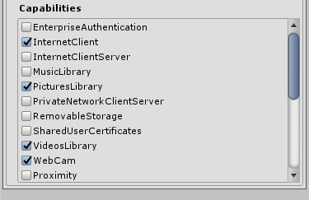

HoloLens has a mobile-class GPU. If your app is targeting HoloLens, you'll want the quality settings tuned for fastest performance to ensure we maintain full framerate:

1. Select **Edit > Project Settings > Quality**
2. Select the **dropdown** under the **Windows Store** logo and select **Fastest**. You'll know the setting is applied correctly when the box in the Windows Store column and **Fastest** row is green.